**Alternation of generations,** also called Metagenesis, or Heterogenesis, in biology, the alternation of a sexual phase and an asexual phase in the life cycle of an organism. The two phases, or generations, are often morphologically, and sometimes chromosomally, distinct.

In [algae](https://www.britannica.com/science/algae), fungi, mosses, ferns, and [seed](https://www.britannica.com/science/seed-plant-reproductive-part) plants, alternation of generations is common; it is not always easy to observe, however, since one or the other of the generations is often very small, even microscopic. The sexual phase, called the [gametophyte](https://www.britannica.com/science/gametophyte), produces gametes, or sex cells; the asexual phase, or [sporophyte](https://www.britannica.com/science/sporophyte), produces spores asexually. In terms of chromosomes, the gametophyte has a single (i.e., monoploid, or haploid) set, and the sporophyte has a double (diploid) set.

Among animals, many invertebrates have an alternation of sexual and asexual generations (e.g., protozoans, jellyfish, flatworms), but the alternation of haploid and diploid generations is unknown.

Source: Britannica

**How do plant life cycles compare to animal life cycles?**

At first glance, a comparison of plants and animals suggests that members of these groups have very little in common. A closer look at their life cycles, however, reveals similarities that often surprise people. Just like animals, plants are characterized by sexual reproduction, with new individuals being formed by the union of sex cells. While plants cannot be said to have separate sexes in the same way that animals do, they form sperm and eggs in male and female structures, just like animals. And, just like the sex cells of animals, the sperm and eggs of plants carry half of the hereditary material in the parent’s genome. Beyond this, however, plant life cycles are unique in that they exhibit a process found in no other group of organisms — alternation of generations.

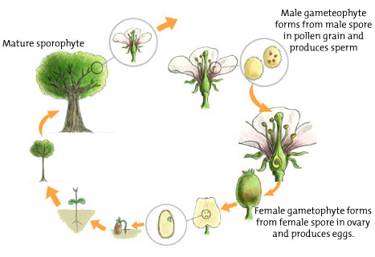

Alternation of generations in a flowering plant

**What is alternation of generations?**

In an animal life cycle, male and female parents each create sex cells (sperm and eggs) that unite to form a fertilized egg and develop into an offspring organism. Plants, likewise, have sperm and eggs in their life cycles, but these are produced by an intermediate stage between the adult and the offspring.

These stages, which were explained by Dr. Judith Sumner in the video, can be thought of as different "generations" within the same life cycle. The adult generation produces spores, while the spore generation produces sex cells. The scientific terms for these generations are sporophyte (sporo = spore; phyte = plant; therefore, spore-producing plant) and gametophyte (gameto = sex cell; phyte = plant; therefore, sex-cell-producing plant).

In the body cells of animals, chromosomes exist in pairs — a condition we’ll call doubles. Animal sex cells have half as many chromosomes as their body cells — a condition we’ll call singles. In an animal life cycle, the sex cells are the only cells where chromosomes exist as singles. The rest of the life cycle involves body cells that carry chromosome doubles. This is where plants differ. In plants, one *entire* generation carries its chromosomes as singles, while the other carries its chromosomes as doubles. Let’s take a closer look.

When we look at a plant, we’re almost certain to be looking at the sporophyte generation. The sporophyte generation carries its chromosomes as doubles. In this sense, it is analogous to the adult animal, which also carries its chromosomes as doubles. The sporophyte generation, as its name indicates, produces spores. Spores carry chromosomes as singles. The spores then develop into the gametophyte generation.

In most plants, the gametophyte is tiny compared to the sporophyte. As its name implies, the gametophyte generation produces sex cells — sperm and eggs. Like the gametophyte itself — and like the sex cells of animals — the sex cells carry chromosomes as singles. Fertilization brings chromosome doubles back together in the fertilized egg. The life cycle is completed with the development of the sporophyte, which carries chromosomes as doubles.

**What is the significance of this?**

Life scientists have developed several theories to account for the evolution of alternation of generations in plants. One theory has to do with having the “best of both worlds” in terms of variation in a population. In the formation of spores, only one parent contributes the hereditary material. This could be beneficial if that parent exists in a stable environment — it creates offspring with the same characteristics that allowed it to survive and reproduce. With sex cells, two parents are involved, and a mixing of hereditary material occurs. This results in offspring that vary from both parents and from one another. This could be beneficial in a changing environment where some variants are likely to be suited to that environment while others may not be.

**How can alternation of generations be observed in the plant kingdom?**

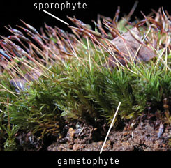**Mosses**  
It’s actually easiest to observe alternation of generations in the most primitive group of plants: the mosses. If you’ve ever looked closely at a moss, you may have noticed a tiny leafy green mat from which a stalk protrudes at certain times of the year. The stalk is the sporophyte. From its cap, spores are cast that land on the ground and develop into the gametophyte—the leafy green mat. Special structures within the mat produce sperm and egg. The sperm swim to the eggs and fertilize them. A stalk, which remains attached to the mat, results from each fertilized egg. The moss life cycle thus requires ground water in order to be completed—this is why mosses are always found in moist environments.

**Ferns**Another major plant group includes the ferns. In ferns, the different generations exist as distinct individuals. The graceful fronds, or leaves, that we see adorn the sporophytes. If you look under the fronds of a mature plant, you’ll see structures where the spores are produced. The spores are cast from these structures onto the ground, where they develop into gametophytes. The gametophytes are tiny heart-shaped structures that are nearly invisible to the naked eye. They require a moist environment to develop and, once mature, produce sperm and egg. Like the mosses, the sperm require water to swim to the eggs, with each fertilized egg developing into the familiar, frond-bearing sporophyte.

|  |  |
| --- | --- |
| fern labeled | fern with sporangia |
| Ferns with gametophye and sporophyte sections | Christmas fern with sporangia |

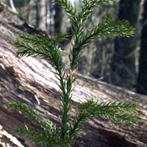

Conifer sporophyte

**Conifers**  
In the conifers, the stately needle- and cone-bearing trees are the sporophytes. Conifers actually have two different types of cones. The female cone is probably what you are familiar with, bearing hard, woody scales. In a structure on top of each scale of the female cone, female spores are produced, which develop into the microscopic female gametophyte — a plant that consists of only one cell for most of its existence. The gametophyte remains inside the structure that produced it, which itself remains attached to the scale.

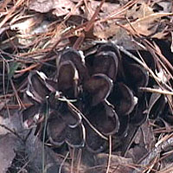

Female cone

The male cones are much smaller than the female cones and are the structures that produce copious amounts of yellow “dust” in the Spring. On the underside of each tiny scale are structures that produce numerous male spores, which develop into gametophytes that consist of just four cells. The gametophyte and its covering are the pollen, which is carried by wind to the female cone. Pollination occurs when pollen lands at the sticky base of the scale and the sperm grows to and fertilizes an egg, which eventually forms a papery seed on top of the scale. Note that, unlike mosses and ferns, water is not required to bring sex cells together and that the embryo develops in a seed, where it is protected from drying-out and is supplied with food.

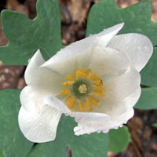

Flowering plant (sporophyte)

**Flowering plants**  
Alternation of generations in flowering plants is essentially the same as in the conifers (and just as complicated), except that flowers represent the sporophyte. Female structures, called ovaries, contain structures that produce the female spores. These develop into a seven-celled gametophyte inside the ovary — you can think of it as a tiny plant inside a plant. The male structures, called stamens, produce the pollen. As in the conifers, the male gametophyte develops inside the pollen grain.

Pollen from the male parts of one flower is delivered to the female parts of another flower in various ways: wind, insects, birds, bats, etc. When pollination occurs, sperm form and grow to the ovaries, where they fertilize eggs. A fertilized egg develops into a seed inside the ovary. Again, notice that this process does not require water to bring sex cells together, and that a seed protects the developing embryo. The difference between conifers and flowering plants is that the seeds develop within an ovary (the fruit) rather than on top of a cone scale.

**How did land plants evolve?**

There is overwhelming evidence that the ancestors of modern land plants evolved in aquatic environments, where they existed and diversified over millions of years. From one group of these organisms — probably ancestors of modern species of protists known as green algae — emerged a new branch on the tree of life. From this branch arose four groups of land plants, including the mosses, the ferns, the conifers, and the flowering plants. These groups are believed to represent a sequence that reflects the evolutionary history of land plants.

**What adaptations occurred with the transition from water to land?**

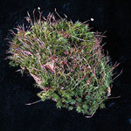

Moss, a primitive land plant

**Body support**As plants evolved from aquatic to terrestrial environments, several obstacles stood in the way. One obstacle was structural support. In water, organisms are buoyant and the effects of gravity are minimal. Even among larger forms, like kelps, structures with gas-filled vesicles allow them to float. On land, however, if a plant is to grow tall, it needs to withstand the forces of gravity. What adaptations allowed plants to get tall? Rigid cell walls developed to provide support, as did different types of supportive tissues — the woody tissue layers of trees are good examples. The mosses lack these tissues, and are thus limited to a “lowly” existence on the ground. This type of support is found in the ferns, but is fairly primitive. There are thus few ferns that grow more than a meter above the ground. It is in the conifers and flowering plants that we observe the most well-developed adaptations of this nature.

**Transport of materials**

A second challenge to life on land was the distribution of water and other materials to each cell. In aquatic forms, transport occurs directly from the surrounding environment. On land, however, plants must get water and other materials from the soil. What adaptations allowed taller plants to obtain these materials? During plant evolution, systems of “conducting vessels”—tube-like structures—developed that function to transport materials up, down, and around the plant. A differentiation of plant parts also evolved: leaf cells that specialize in making food; stem and branch cells to provide support; and root cells to transport nutrients from the soil. This differentiation into “true” leaves, stems, and roots made it possible for different parts of plants to fulfill different roles — all of which provide support for plants to live away from water and become tall at the same time.

**Fertilization**

A third challenge during the transition to land involved bringing sex cells together. In water, sperm are able to swim directly to eggs. On land, this can only happen in moist environments—and this is exactly what happens with mosses and ferns. Other land plants, however, exist away from such environments. What adaptations allow fertilization to occur in these plants? The answer is found in alternation of generations. The sporophyte generation—the adult generation that produces spores— produces microscopic gametophytes within special structures that provide water and nutrients. The male gametophytes, which form non-swimming sperm, develop within pollen grains. The female gametophytes, which produce eggs, develop on scales (in conifers) or within ovaries (in flowering plants). Pollen is adapted to use wind to transport sperm to eggs, which replaces the need for water.

**Development and dispersal of the embryo**

A fourth challenge for land plants resulted in the evolution of seeds. In aquatic environments, a fertilized egg can develop into an embryo that is never in danger of dehydrating. In addition, the embryo can receive water and nutrients directly from the surrounding environment. The opposite is true on land. On land, an embryo can dry out rapidly and exists in an environment where water and nutrients exist in the ground. Seeds represent adaptations that conquer these challenges. Seeds enclose an embryo in a moist environment. And, tissues within seeds provide food for a developing embryo. Finally, seeds represent a way of dispersing the young of plants away from water as well as away from the parent plant. The seed plants include the conifers and flowering plants. Mosses and ferns, which do not produce seeds, still depend on water for the above functions.

**Transition From Water to Land**

|  |  |  |  |  |
| --- | --- | --- | --- | --- |
| **Plant Group** | **Mosses**  **moss** | **Ferns**  **fern** | **Conifers**  **conifer** | **Flowering Plants**  **flower** |
| Stiff support tissue | absent | present | advanced | advanced |
| Conducting Tissue | absent | present | advanced | advanced |
| True leaves, stems, and roots | absent | present | advanced | advanced |
| Pollen | absent | absent | present | present |
| Seeds | absent | absent | exposed on scale | enclosed in fruit |
| Flowers and fruits | absent | absent | absent | present |
| Water required for fertilization | yes | yes | no | no |

Source: Annenberg Learner